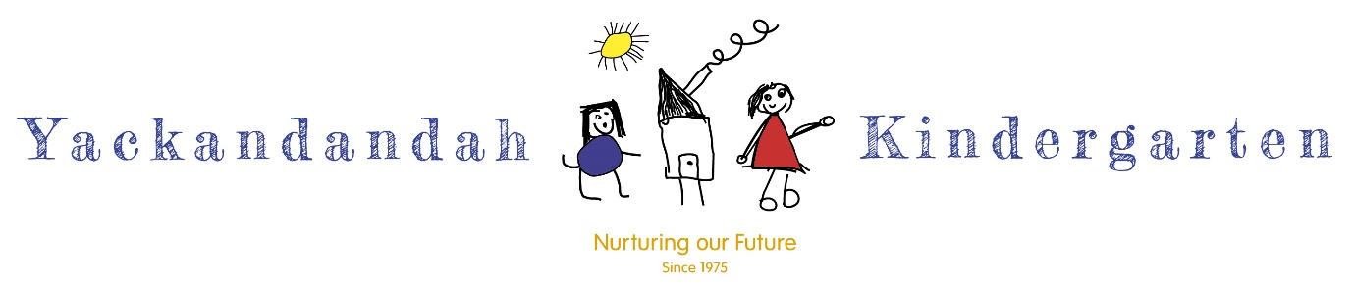

**STAFF HEALTH & WELLBEING POLICY 2021**

**Quality Areas 4 & 7**

Purpose

Yackandandah Kindergarten will promote the health and wellbeing of all staff through the six domains identified through the Achievement Program, developed by the Victorian Department of Health and Human Services and the Department of Education and Training. They are:

1. Learning and skills
2. Healthy social environment
3. Healthy physical environment
4. Healthy policies
5. Community partnerships and engaging children
6. Young people staff and families.

This policy confirms our commitment to:

* providing our staff with a safe, healthy and supportive environment in which to work
* recognising that the health and wellbeing of our staff is essential and provides a strong foundation that will benefit each individual; children, families and the wider community

creating a supportive workplace culture where healthy lifestyle choices are valued and promoted

providing staff with ready access to health information and services

ensuring an equitable workplace that is supportive of the diverse community that our kindergarten reflects.

Policy statement

Yackandandah Kindergarten is committed to creating and maintaining a workplace environment where the health and wellbeing of all staff is highly valued. We acknowledge that a positive workplace environment encourages and supports all staff to maintain or adopt healthy lifestyles. While everyone has a responsibility to maintain and support our healthy workplace, individuals have the right to choose their level of participation.

As contributors to our workplace environment; all staff, contractors, visiting students and volunteers are included in the scope of this policy.

Responsibilities

**Management** has a responsibility to:

* ensure all staff are accepted and valued as individuals and professionals
* ensure effective communication channels are in place
* enable and cultivate a workplace culture that promotes connectedness, is inclusive and provides support
* recognise staff for the work they do and provide relevant and regular feedback
* create opportunities for staff to provide feedback to management
* provide professional development and resources as required, to support staff to enhance knowledge of their own health
* ensure that the staff /volunteers/ visiting students are aware of the policy at induction and have the opportunity to provide feedback

Management also has a responsibility to monitor the implementation of this policy by ensuring it is readily accessible to all staff, that staff are encouraged to contribute at review and that any changes to the policy are discussed.

**Staff** have a responsibility to:

* read, fully understand and action the staff health and wellbeing policy in their work roles
* support the policy to ensure the workplace culture is supportive and positive for staff health and wellbeing
* be respectful of each other
* comply with the policy at all times while completing work related duties

inform management if they believe the policy is not being followed, gaps are identified or if there is feedback that could improve implementation of the policy.

Procedures

Yackandandah Kindergarten will provide a healthy physical and social environment and promote awareness of key health issues for staff that supports:

* healthy eating and oral health
* physical activity
* environmental awareness and sustainable practices
* tobacco control/ smoke free environment
* safe environments
* mental health and wellbeing
* sun protection.

Our workplace will:

* encourage staff to provide input into the development and implementation of health and wellbeing initiatives within the service
* promote staff participation in wellbeing initiatives beyond the scope of the service
* engage health professionals, services and organisations who can support promotion of staff health and wellbeing.

Relevant legislation and policies

* [National Quality Framework, Standard 7.1](http://www.acecqa.gov.au/Leadership-and-service-management)  Effective leadership promotes a positive culture and builds a professional learning community
* Occupational Health and Safety Policy 2020
* The Department of Education and Training: [Principles for Health and Wellbeing](http://www.education.vic.gov.au/about/department/Pages/wellbeing.aspx)
* Yackandandah Kindergarten Sun Protection Policy 2019
* Yackandandah Kindergarten Rest and Relaxation Policy 2020
* Yackandandah Kindergarten Staff Handbook 2021

Monitoring and review

The *Staff Health and Wellbeing Policy* will be monitored by educators, staff, families, management and the Health & Wellbeing Team. It will be reviewed at least once every 3 years as part of a policy review schedule.

Related documents

* [Healthy Together Achievement Program for Workplaces](http://achievementprogram.healthytogether.vic.gov.au/workplace)
* [Heart Foundation: Workplace Wellness](http://www.heartfoundation.org)

[Healthy Workers Initiative](http://www.healthyworkers.gov.au/internet/hwi/publishing.nsf/Content/why)

Endorsed March 2021

**Next review date: 2024**