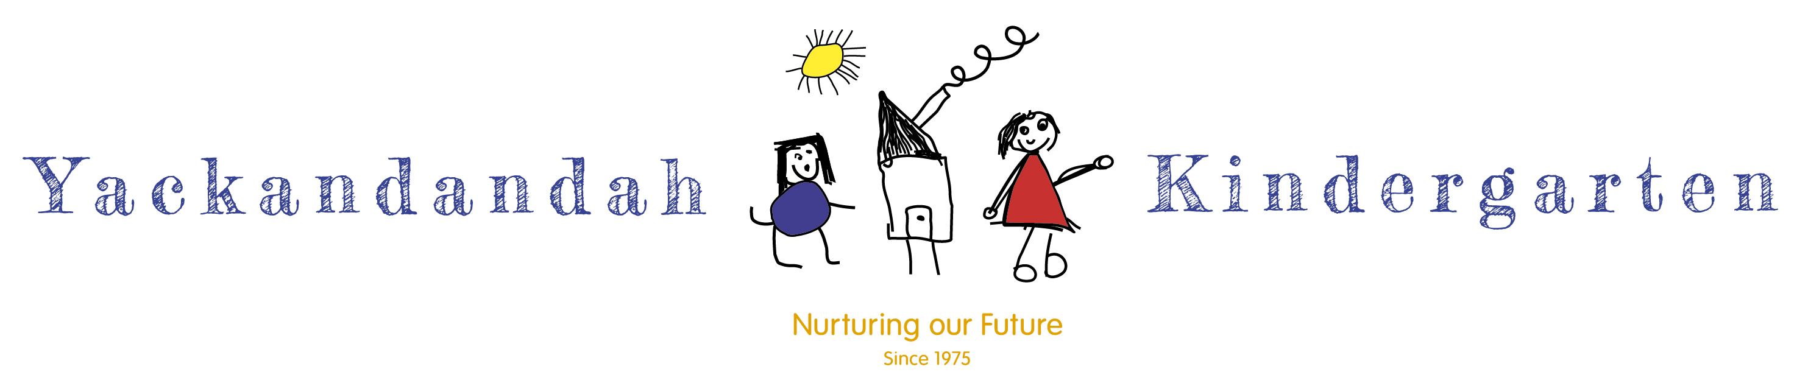
CODE OF CONDUCT POLICY FOR FAMILIES AND VOLUNTEERS 2022
Quality Area 4

VALUES:

The Yackandandah kindergarten provides an open, welcoming and safe environment. We believe that families and volunteers play a crucial and valuable role in the effective operation of the Kindergarten and in enriching the children’s program.

The Kindergarten is committed to:
- The well being of each child having fundamental importance
- The provision of a safe and secure environment
- Providing an open, welcoming environment where everyone’s contribution is valued and respected
- Encouraging families and volunteers to support and participate in the Kindergarten’s programs.

The Kindergarten is a place of learning for young children and therefore the rights of the child will be considered first and foremost.

PURPOSE:

The aim of this policy is:

- To provide guidelines to promote desirable and appropriate behaviour to ensure that all interactions with children and adults will be respectful, honest, courteous, sensitive, tactful and considerate.
- To assist in ensuring the safety and well being of children, families and staff

GUIDELINES:

- This Code of conduct applies to all adults, including parents, care givers, volunteers, extended family, visitors and other association members involved in any activities related to the Kindergarten.
- All families of children attending and volunteers involved with the kindergarten will be required to read and sign the Code of Conduct to formally acknowledge that they understand what is acceptable behaviour from adults in a preschool environment and agree to comply with the requirements.
- Families will be given a copy of the Code of Conduct on enrolment.
- A breach of the Code of conduct may result in formal disciplinary action by the Committee of management and may lead to exclusion from the Kindergarten.
- All adults are expected to follow the principles of:

Safety | Comply with all policies and procedures of the Kindergarten. These are displayed at the Kindergarten.
Ethical Conduct | Always act in the best interests of children, their families and users of the service.
Support | Work in a cooperative and positive manner.
Communication | Use courteous and acceptable verbal and non-verbal language in all communication. Refrain from the use of profane, insulting, harassing and otherwise offensive language.
Respect | Value diversity and refrain from all actions and behaviour that constitute harassment or discrimination.
Confidentiality | Comply with the Kindergarten privacy policy. Respect the confidential nature of information gained, or behaviour observed, whilst participating in the program, in relation to other children and adults.
Children’s Program | If participating in the program seek guidance and direction from staff. Behaviour guidance of the children is the responsibility of staff, immediately refer an issues or concerns related to managing children’s behaviour to staff.

- Behavioural practices to follow:
In relation to children
- Be a positive role model at all times.
- Always speak in an encouraging and positive manner.
- Listen actively to children and offer empathy, support and guidance where needed.
- Regard all children equally and with respect and dignity.
- Physical contact with children other than your own should be avoided unless directed by staff or if the safety of a child is compromised (this should be reported immediately to staff).
- Inform children if physical contact is required for an activity and ask them if they are happy to proceed.
- All interactions with children should be undertaken in full view of other adults.
- Never do things of a personal nature for a child that they can do themselves. (eg. assisting them going to the toilet or changing their clothes)

In relation to other adults (including staff)
- Use respectful, encouraging and accepting language.
- Respect the rights of others as individuals.
- Give encouraging and constructive feedback rather than negative criticism.
- Accept staff decisions and follow their directions at all times. Speak with the staff member if you have a problem with complying with any directions.
- Be aware of routines and guidelines for children’s play within the Kindergarten, abide by them and seek advice when unsure.
- Be aware of emergency evacuation procedures.
- Discipline of children is the responsibility of staff and therefore any matters or concerns related to managing children’s behaviour should be referred to staff immediately.
- Avoid approaching staff to discuss a child during the session. Seek an alternative time when staff are free from contact duties with children.
- Refrain from public criticism of children and adults at the centre.

- Any issues or grievances should be directed to the Educational Leader or Principal as outlined in the Complaints Policy.
- Under no circumstances should a child, parent or member of staff be approached directly in a confrontational manner.
- Smoking is prohibited on the Kindergarten property at all times.

In General
- The Kindergarten and staff are responsible for the children that are enrolled and signed in, that is those children attending their Kindergarten session.
- When parents bring other children to the Kindergarten the staff are not responsible for these children and will not supervise them.
- Adults are responsible for all children who accompany them, for example while on duty, drop off and pick up time, ensuring they do not inhibit or disrupt the program in any way.
- Parents are responsible for children’s behaviour when attending other activities and the child is not signed into the program, for example working bees, family night.

OUTCOMES EXPECTED:
That all staff, families and volunteers attending the Yackandandah Kindergarten will conduct themselves in line with the principles outlined in this policy.

RESPONSIBILITY:
The committee of management is responsible for ensuring all families, staff and volunteers are provided with a copy of this policy upon arrival, employment and enrolment.
The Educational Leader and Principal are responsible for implementing the standards of conduct as set out in this policy.
On notification of a potential breach of the Code of Conduct the Educational Leader or Principal will activate the complaints policy.
Emergency situations involving a breach of the Code of Conduct (eg. violence that has been threatened) will be dealt with by the Educational Leader / School Principal.

ASSOCIATED POLICIES AND LEGISLATION:
- Privacy Policy
- Complaints Policy
- Education & Care Services National Law Act 2010
- Education & Care Services National Regulations under the Education & Care Services National Law
- Child Wellbeing and Safety Act 2005
- Occupational Health and Safety Act 2004 (Vic)
- Disability Discrimination Act 1992 (Cth)
- Sex Discrimination Act 1984 (Cth)
- Equal Opportunity Act 2010 (Vic)
- Fair Work Act 2009

REVIEW:
In accordance with the Policy Review Table, the Code of Conduct for Families & Volunteers will be scheduled for review in 2025.

Appendix 1

AS PRINTED IN OUR ENROLMENT FORMS

Code of Conduct for Families & Volunteers

Acknowledgement of receipt

I hereby acknowledge that on ………………………………………….(date) I received a copy of the Code of Conduct for the Yackandandah Kindergarten.

I have read this Code of Conduct, I understand its contents and I agree to abide by the principles and practices set out within.

I understand that the Educational Leader / Licensee / Principal of Primary School will deal with any breach of this Code of Conduct and any serious breach could lead to the withdrawal of my child (ren)’s place at the kindergarten.

I understand that a signed copy of this statement of commitment will be kept on file while my children remain at the Kindergarten and will be disposed of at the end of this time.

Signature……………………………………………………………. Name …………………………………………………. Date ……………

Witness Signature……………………………………………… Name ………………………………………………….. Date ……………

